Pre-Reading

Mother is in the Cafeteria
In this packet you’ll be learning words related to food, and so the first word is 食堂 (shi2tang2) the first character is an adjective that relates to food or a meal, it is a pictograph made to look like a serving dish with a lid. The second character 堂 means “hall” as in a big room. This character is also used in 天堂 which literally means hall in the sky, but we would use it as “heaven.” The next word is 西红柿炒鸡蛋, this is the name of a popular dish in China, and it is composed of three words. The first word 西红柿 (xi1hong2shi4) literally means western red persimmon, however we simply refer to it as a tomato, the last word 鸡蛋 (ji1dan4) which literally means Chicken egg. The word in between this words is 炒 (chao3), now these character is broken into two radicals that you should recognize 火 (huo3) and 少 (shao3) the first radical (fire) give this character it’s meaning of stir-fry while the second radical gives a hint to how to pronounce it, shao sounds like chao. So 西红柿炒鸡蛋 is tomato stir-fried eggs. You could also say 牛肉炒土豆 beef stir-fried potatoes. The next word is 馒头 (man2tou2), the first character 馒 has a food character on the left, in traditional characters this food character would look like 食. The second character is 头, which means head, now these two characters combine to mean steamed bun, which is a common staple food in China. The next word 选择 (xuan3ze2) The first character means to select or choose it has the same under radical as 过 and the part in the middle is the same as 先 as in 先生. The second character 择 has a hand radical on the left, the same as in 打， this character means to pick out, and you can imagine that you need your hand to pick something out. These two characters together mean to choose, as a noun it means option or selection. The next word 另外 (ling4wai4) which simply put means other, or other than. 肉 (rou4) is a character that appears a lot in this section. It means meat, it is a pictograph of a slaughter house with meat hanging from the ceiling. 肉will combine with the animal name to get your different types of meat. 鸡肉is chicken meat, 牛肉 is cow meat or beef, 羊肉is sheep meat or mutton, 猪肉 is pig meat or pork, this 肉character will also appear in a dish name such as 回锅肉 (hui2guo1rou4) the first 回 you should remember as 回家 or return home, the second character 锅has a metal radical on the left and it means pot, and the last character is obviously 肉 or meat. So this means meat that has returned to the pot, we call this dish twice cooked pork. Lastly you’ll see 肉in the word 肥肉, the first character 肥 (fei2) which means fat as in not lean. Notice the moon character 月 that is also used in the character for overweight 胖. The next character is 菜 (cai4), this character means both vegetable and dish. I can say this 菜 叫什么？ If I want to know the name of a dish. This is very important when living in China, because dishes have very odd names. The next word is a famous dish in China that is also quite common here in the U.S. 宫保鸡丁 (gong1bao4ji1ding1) if you sound this word out you might get that it is Kung Pao Chicken. The last character 丁 refers to the shape of the chicken, it is usually cubed for this dish. 黄瓜 (huang2gua1) is a yellow melon, or a cucumber. The last thing we want to look at is 吃完 (chi1wan2). The first character you should remember as eat. The second character is to end something. You can place it after any verb to signal that it has been completed. So 说完 is finished speaking, 写完 is finished writing and 做完 is finished doing.

Story Character Count = 110

Vocabulary/Writing

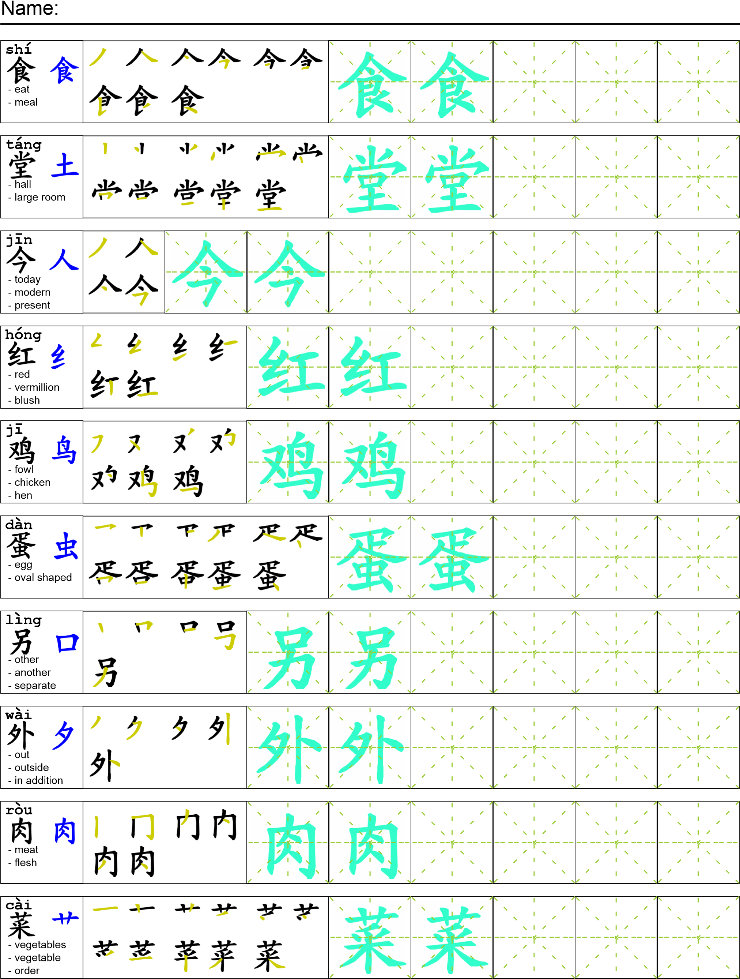
Reading

这时候我妈妈在食堂吃饭。今天她吃了西红柿炒鸡蛋还有一个馒头。今天食堂里有两个选择：一个是西红柿炒鸡蛋另外一个是回锅肉。我妈妈不喜欢回锅肉因为肥肉太多。她最喜欢的菜是宫保鸡丁，因为他喜欢吃鸡肉和黄瓜。她吃完饭就回家。她每天是第一个回家的人。
Task Completion

Once all tasks are complete turn the assignment in to collect the points for the project.
Task 1: Trace the vocabulary and copy the text into your notebook.

Task 2: Answer Comprehension Questions.

Task 3: Write the Pinyin for the Reading.

Task 4: Translate the Reading into English.

Task 5: Record yourself reading the passage.

Comprehension Questions
- 你喜欢什么肉？
- Give me three examples of how to use 完.
- 我妈妈最喜欢什么菜？
- 我妈妈为什么不喜欢回锅肉？

